Node-Red Guide for Bags Tracking and Sorting Sub-problem
Every single conveyor belt system has its own PLC known as the Groov RIO by Opto22. We use Node-Red for wiring up together hardware and API’s, which is a browser-based editor that provides a convenient way to create, edit and deploy flows using a variety of nodes provided.

How to open Node-Red
Depending on which PLC you’re trying to communicate with (1,2,3,4,5 or 8), access the respective link: https://ideasplc3.u waterloo.ca/manage/home (Replace the 3 with the appropriate number)
This will take you to either…
  - “Your connection is not private” page:
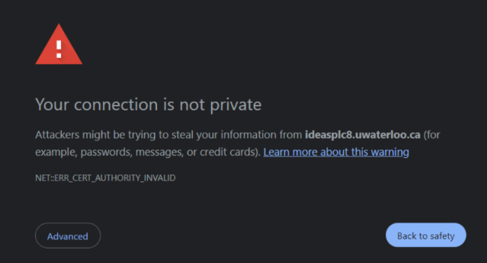
If it is the security page, click “advanced” and then click “proceed to… “. This should take you to the log in page, or a page that looks like this:
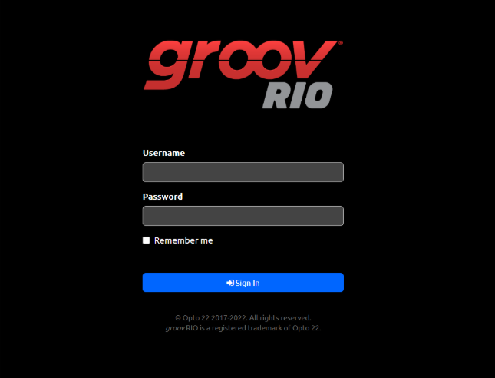
If it is the login page, the following login information works for ALL PLCs:
  - Username: ideasclinic
  - Password: plc123

This is the HOME page:
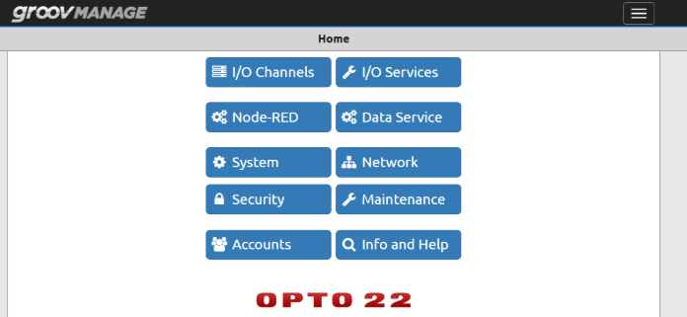

There are a few relevant things on this page:
  - I/O Channels:
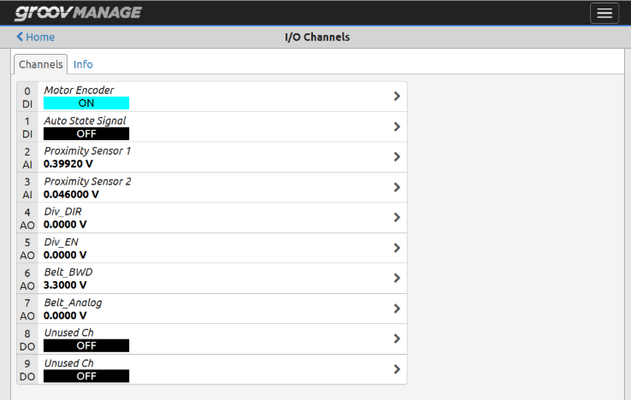
The I/O Channel page tells you which sensor/component is connected to which channel, and it shows you the current value of that channel.
You can use these channels to directly control the PLCs if the conveyers are in AUTO mode.

  - Node-RED:
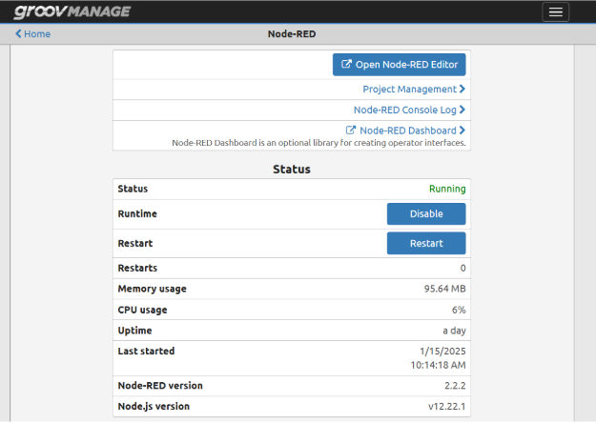

Select “Open Node-RED Editor”. You’ll see something that vaguely looks like the following:
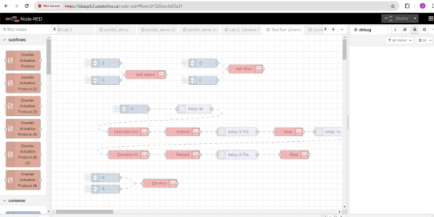
You’ve now accessed the Node-RED Editor.

Navigating Node-RED
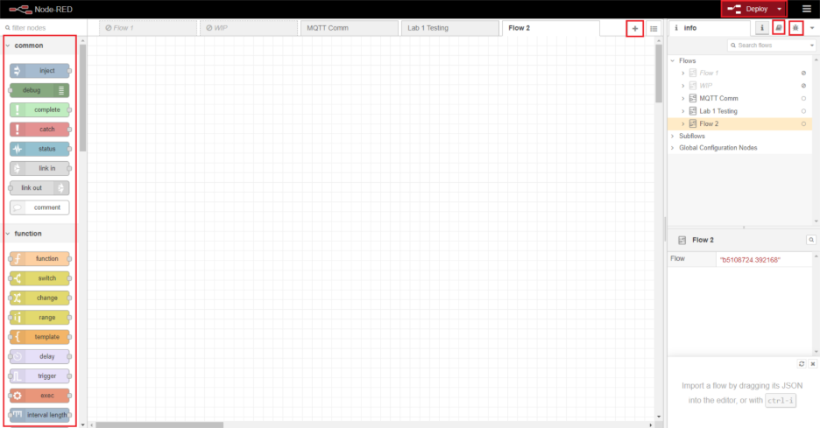
Node palette
- On the left of the screen is the node palette where you can drag and drop nodes into the flow. You can search for nodes in the filter nodes section or use the scroll bar to view all the nodes available.
Flow management
- The plus icon at the top of the flow editor is to create a new flow. You can easily switch between the flows you create by clicking on which flow you would like to view.
- Under the “flows” tab at the right side of [Fig.1], you can see the current active and inactive flows. Make sure later that your current flow is the only one active.
Node Help
- You can view the node help by selecting the button with the book in the top right of the screen. This will show a list of all the nodes you have available as well as detailed notes on the node itself.
Debug
- You can view the debug output by pressing the button with the bug in the top right of the screen. This simply shows the debug message outputs that you have setup in your flow. It can be set to display all debug messages, messages for a specific flow, or selected debug nodes.
Configuring nodes
- When you drag and drop a node from the palette on to the editor, double click the node to access the configuration settings. The configuration for all nodes is different and will be detailed further in the next section.

Reference Table for Important Nodes
Table 1 - Common Nodes in Node Red
Node | Description | Configuration Notes
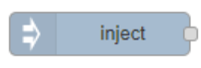 | - Inject a message payload into a flow.  - Can be manually injected, or automatically at regular intervals.  - The payload can be set to a variety of types, such as strings, Boolean, numbers, and even JavaScript expressions/objects.  - Will be used to begin the conveyor belt test. | - Can inject to multiple message properties (payload, topic etc.) to different value types.  - Can set time to inject after clicking.  - Can set to repeat.
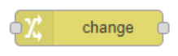 | - Used to set, change, delete or move properties of a message, flow, or global.  - Specify a property to change, and what to change it to. | - Set, change, delete or move a specified message property.  - Can add multiple changes in one node.  - Will be used for setting msg.payload to true or false to actuate the channels.
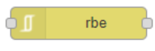 | - Report by exception is used to only pass data when a value changes.  - Will be used when polling input from the Groov Rio to avoid constant reporting. | - Multiple modes  - 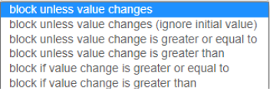  - Specify the message property to look at.
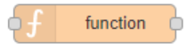 | - Very powerful node that can run JavaScript code against the message being received.  - Will be used to calculate belt speed and positioning. | - Three programmable sections, setup function and close.  - Code written in setup runs once at start up.  - Code written in function runs every time the function node is run.  - Code written in close will be run when the node is stopped or re-deployed.
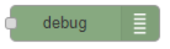 | - Can be configured to display a selected message property, the entire message, or a JSON data expression.  - Will be used when debugging to ensure that values are being read, and calculations are correct. | - Can be configured to send to debug window, system console, and/or node status.  - Configurable output, typically msg.payload is used.
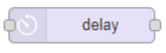 | - Delays a message from passing through a flow for a specified or variable amount of time.  - Will be used when timing how long it will take for the box to reach the diverter, as well as how long the diverter needs to run for. | - Can be set to be a fixed delay, random delay, or variable delay.  - Variable delay is assigned by assigning the msg.delay property using a change node.
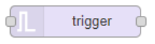 | - When triggered, can send a message, and then optionally a second message, unless extended or reset. | - The trigger block can be configured to send a hard coded value or values stored the in the msg, flow or global context.  - It can also be configure to send a message after a certain amount of time passes.  - Sending a msg object to this node with a msg.reset value any timeout or repeat currently in progress will be cleared and no message triggered.
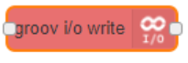 | - Writes a value to a Groov Rio I/O channel.  - Will be used to turn on/off the diverter/belt.  - It will read the msg.payload that enters it, so change nodes will be used to easily set the msg.payload. | - Must configure Data type to match the one set in the Groov manage page.  - Set Module index = 0.  - Channel index is set to whatever channel you are writing to.  - Set Device to “localhost”.  - Set value to msg.payload.  - Click the pencil icon next to device to access more configuration settings.  - Set Address to localhost  - Retrieve the API Key from the Groov manage page by selecting Accounts > Users > Local User and copy the API key and paste it into API Key.
 | - Polls the I/O of a Groov Rio channel and produces a message when a value changes.  - Will be used to read from the proximity sensor channel, and motor encoder channel. | - Set up is the same as the Groov I/O write node, except instead of setting the value, you set the dead band. the Deadband setting controls the generation of new messages. A message is only generated if the new value is beyond the deadband compared to the previous sent value

MQTT Guide for Bags Tracking and Sorting Sub-problem

MQTT is a lightweight network protocol commonly used for IoT devices to publish or subscribe to a small bandwidth of data. The computer vision software is a proprietary python program running on an Nvidia Jetson Nano connected to a camera. The Nvidia Jetson Nano is a small computer used for small-scale AI and robotics applications. The Jetson Nanos used here run on the ubuntu 18.04 operating system.

Jetson Nano – General Setup & Usage Instructions
Turn on the Jetson Nano by unplugging the USB-C power cable from the back and plugging it back in.
Once the Nano has finished booting, log in using the appropriate password (it may already be logged in in which case you can skip the log in process):
“jetsonideas” for the board labeled industrial 1
“nano123” for the board labeled industrial 2
After logging in, double-click the Terminal icon (black square on the left side of the screen) to open it. In the terminal, run the required Python script to start the application:
python3 <your_program_name>.py
After a short initialization period, the system should begin running, and any connected sensors or cameras will start displaying output (if applicable).
The Jetson Nano processes incoming data (e.g., from sensors, cameras, or other inputs) and can send results to other systems using communication protocols such as MQTT. When configured, it publishes messages to a specified server (IP address and port), allowing other devices or applications, such as Node-RED or a PLC, to receive and use this data.
General Data Flow:
Jetson Nano processes input → generates output → sends data via MQTT → other systems receive and act on it.

Install barcode-reading libraries
OpenCV library is for camera + image processing
ZBar via pyzbar library is for barcode decoding
Install them (Jetson terminal):
sudo apt update
sudo apt install python3-pip libzbar0
pip3 install opencv-python pyzbar

In Node-Red
To subscribe to MQTT for the camera PLC and get a message from the camera, start a new flow and drag an MQTT in node into the flow [Fig.1].
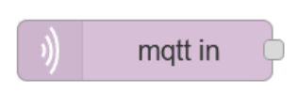
Figure 1: MQTT in Node
Double click the node to access its properties. The server IP and port are 129.97.228.106:1883 and can be entered into the “Server” property exactly like above to establish a connection to the MQTT server. To subscribe to the data published by the computer vision program, use the “MQTT explorer” app to determine which conveyor contains the topic “barcode_detected”.

Access MQTT Explorer
Download and install MQTT onto your device from here: MQTT Explorer | An all-round MQTT client that provides a structured topic overview
When opening the app, the screen below should automatically pop up. 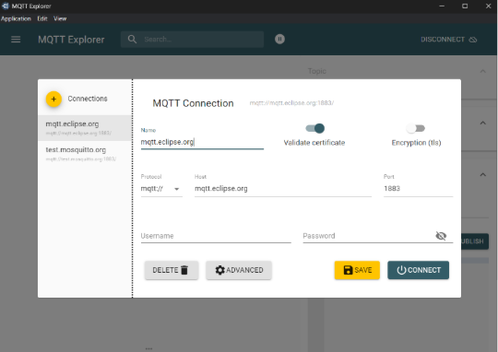
Change the host to 129.97.228.106 and click on CONNECT. The next page should look like this!
